**TestNG Tutorial (With Eclipse)**

**Table of Contents**

[Introduction of TestNG](http://howtodoinjava.com/testng/testng-tutorial-with-eclipse/#introduction)

[Advantages of TestNG](http://howtodoinjava.com/testng/testng-tutorial-with-eclipse/#advantages_testng)

[Installing TestNG onto Eclipse](http://howtodoinjava.com/testng/testng-tutorial-with-eclipse/#install_testng)

[Creating Java Project with TestNG Dependencies](http://howtodoinjava.com/testng/testng-tutorial-with-eclipse/#create_java_project)

[Creating your first TestNG class](http://howtodoinjava.com/testng/testng-tutorial-with-eclipse/#create_testng_test)

[Running TestNG test](http://howtodoinjava.com/testng/testng-tutorial-with-eclipse/#running_testng_test)

**Introduction of TestNG**

TestNG, where NG stands for “next generation” is a test automation framework inspired by JUnit (in Java) and NUnit (in C#). It can be used for unit, functional, integration, and end-to-end testing. TestNG has gained a lot of popularity within a short time and is one of the most widely used testing frameworks among Java developers. It mainly uses Java annotations to configure and write test methods.

**A few of the features that TestNG has over JUnit 4 are:**

* Extra Before and After annotations such as Before/After Suite and Before/After Group
* Dependency test
* Grouping of test methods
* Multithreaded execution
* In-built reporting framework

It is written in Java and can be used with Java as well as with Java-related languages such as Groovy. In TestNG, suites and tests are configured or described mainly through XML files. By default, the name of the file is testng.xml, but we can give it any other name if we want to. TestNG allows users to do test configuration through XML files and allows them to include (or exclude) respective packages, classes, and methods in their test suite. It also allows users to group test methods into particular named groups and to include or exclude them as part of the test execution.

## Advantages of TestNG

Now let’s discover more features/advantages offered by TestNG.

1. Multiple Before and After annotation options
2. XML-based test configuration and test suite definition
3. Dependent methods
4. Groups/group of groups
5. Dependent groups
6. Parameterization of test methods
7. Data-driven testing
8. Multithreaded execution
9. Better reporting

We will discuss these features in more detail in coming ......

## Installing TestNG onto Eclipse

Before we can download and start using TestNG, make sure you have Java JDK5 or above is installed on your system. Also make sure that JDK is set in the system path.

In case you just want to download the TestNG JAR, you can get it from the following URL:

TestNG Jar – http://mvnrepository.com/artifact/org.testng/testng/6.11

Now, let’s start with the installation process of TestNG onto Eclipse. I will try to capture all steps in the process.

1) Open your Eclipse application.

2) Go to **Help | Install New Software**.

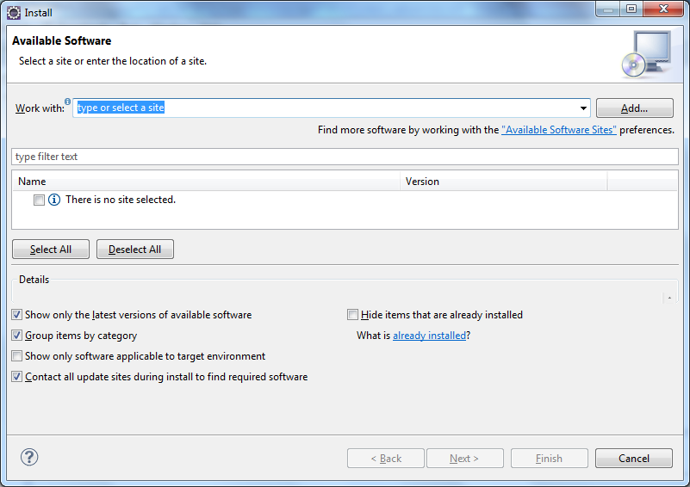

3) **Click on the Add…** button next to the Work with text box.

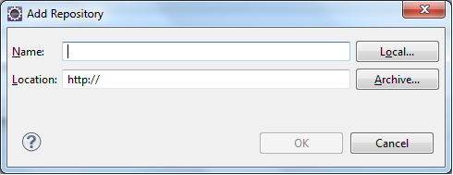

4) **Enter TestNG site into the Name box and enter URL http://beust.com/eclipse into the Location box**. Once done, click on the OK button.

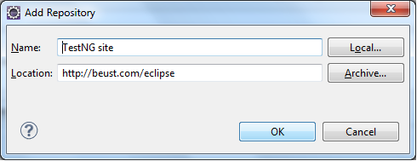

5) On clicking OK, TestNG update site will get added to Eclipse. The available software window will show the tools available to download under the TestNG site.

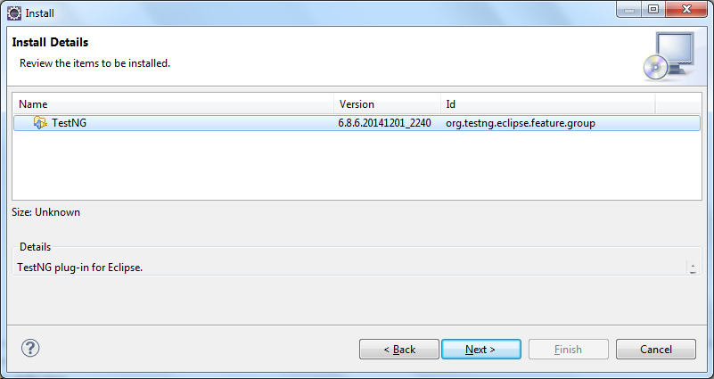

6) **Select TestNG and click on Next**.

7) Eclipse will calculate the software requirements to download the selected TestNG plugin and will show the Install Details screen. **Click on Next on the details screen**.

8) **Accept the License Information and click on Finish**. This will start the download and installation of the TestNG plug-in onto Eclipse.

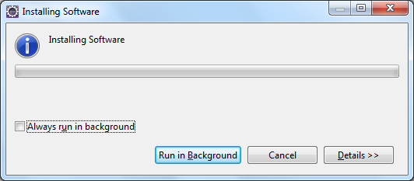

9)In case you get the following **warning window, click on the OK button**.

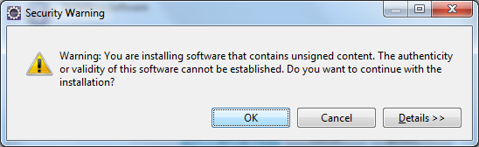

10) Once the installation is complete, Eclipse will prompt you to **restart it**. Click on Yes on the window prompt.

11) Once Eclipse is restarted, **verify the TestNG plugin installation** by going to Window | Preferences. You will see a TestNG section under the preferences window.

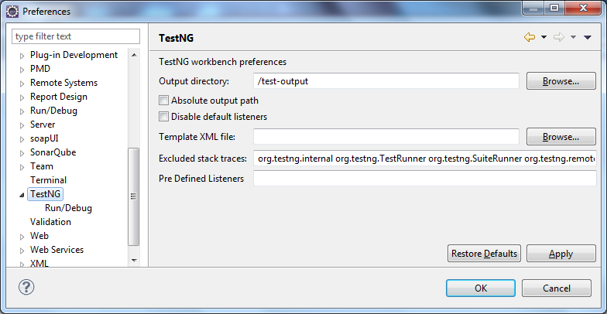

We have successfully installed the TestNG plug-in into our Eclipse installation. This will help us in executing our TestNG tests or suite using Eclipse.

# First Test case with TestNG

## Steps to follow:

1) Press **Ctrl+N** , select “**TestNG Class**” under **TestNG**category and click **Next**.

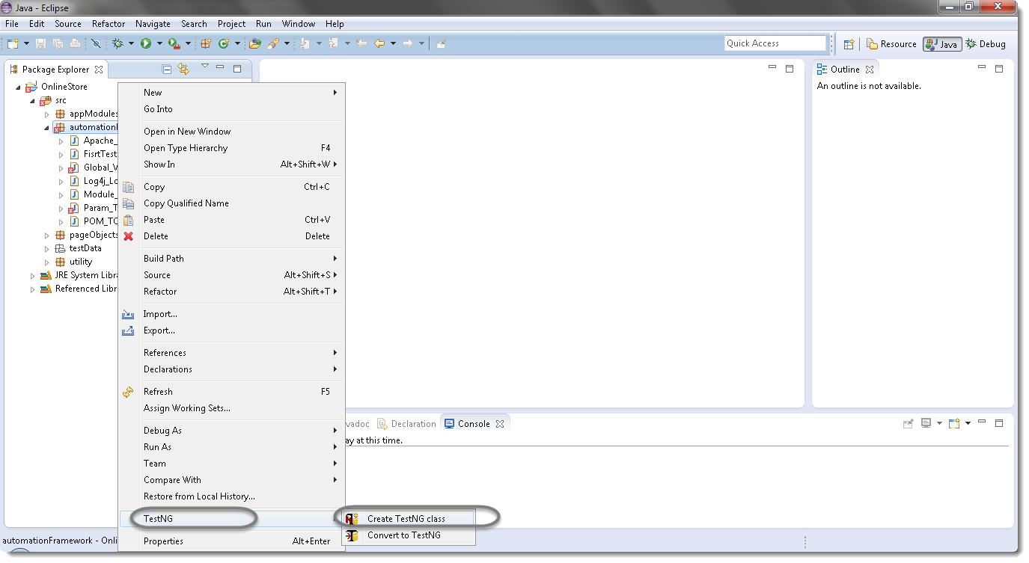

2) If your project is set up and you have selected the Test Case folder before creating TestNG class then the source folder and the package name will be prepopullated on the form. Set class name as ‘**TestNG**‘.

Under Annotations, check “**@BeforeMethod**”, “**@AfterMethod**” and click **Finish**. That’s it.

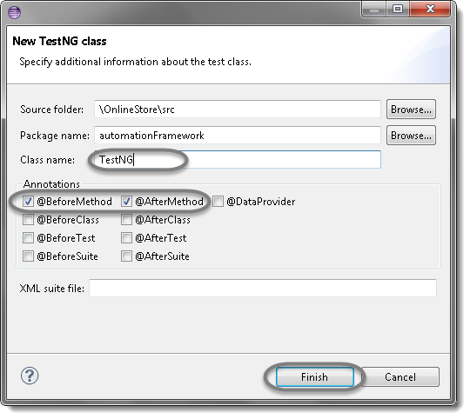

3) Now it will display the newly created TestNg class under the Test Case package(folder). TestNG class will look like the image below with displaying three empty methods. One method f() by default and before & after method, as selected during the creation of the class.

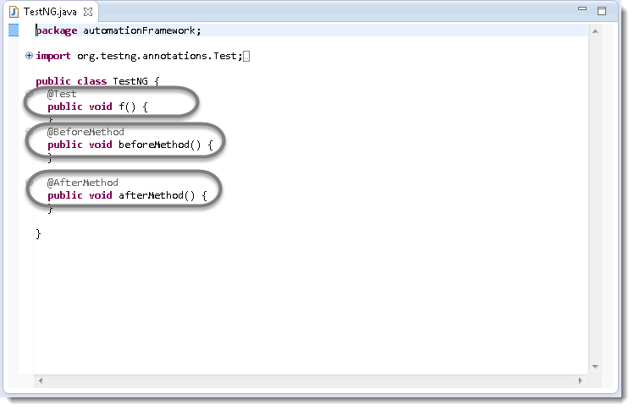

4) Project explorer will look like this with TestNG class.

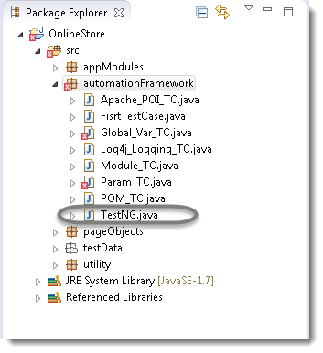

Now it is the time to write the first TestNG test case.

5) Let’s take an example of [First WebDriverTest Case](http://toolsqa.wpengine.com/selenium-webdriver/first-test-case/) and divide the test case in to three parts .

**@BeforeMethod** : Launch Chrome and direct it to the Base URL

**@Test** : Enter Username & Password to Login, Print console message and Log out

**@AfterMethod** : Close Chrome browser